Welcome to Cinderella, one of the largest and most prestigious programs of its kind. Cinderella is in its 37th year, and has given thousands of dollars in scholarships and prizes! Cinderella is a “natural” pageant, without the fancy hair, heavy makeup and glitzy clothes that you see in other systems. Contestants compete in several events:

Photogenic: Please bring one picture (typically head and shoulders) that shows the photogenic qualities of your child. They will be returned and can be any size up to 8X10, color or black and white. Name & age should be on back of photo.

Interview/Baby Playtime: Cinderella uses a “closed” interview backstage with the judges, with contestants wearing simple, tailored dresses or skirts/jackets. The babies (0-2 yrs) will have Playtime with the judges instead, and can bring one chaperone (dress is casual). This phase of competition is designed for the judges to get to know the contestants a little better and to get to see them up close. They will be taken back in groups. Babies are allowed to bring in 1 toy of their choice during Baby Playtime.

Partywear Modeling: Contestants will model one at a time in their formal wear (street length, Easter type dresses for ages 0-12; full-length formals for 13 and up. Babies will model with a chaperone. Modeling is simple and will be taught onstage during a free workshop held onstage right before the pageant.

Casual Wear Modeling: For young ladies ages 3-26 only at the preliminary level (Babies compete in this event at State only). Capri outfits, pants, sundresses, skorts, and skirts are all appropriate (contestants do not generally wear jeans, and no hats or props allowed).

Talent/Tot Personality: Young ladies ages 7-26 are required to compete in Talent competition. They may sing, dance, cheer, tumble, read a poem, play an instrument, etc. Time limit is 2.5 minutes. Please bring your music labeled with your name and turn it in to the sound table before the pageant. Tots (girls 3-6) do not compete in talent, but instead do a short on-stage one-on-one interview with the emcee, called “Tot Personality”.

SCHEDULE OF EVENTS (tentative)

Cinderella Babies (Girls 0-34 Months)
Cinderella Girls ages (3-26 Years):
10:30………..……………….…All Ages Registration
11:00…………….……..Cinderella Model Workshop
TBA.………...…………...……………Baby PlayTime
TBA……………………….…..Cinderella Interviews
TBA………………………..….…Baby Formal Wear
TBA……………………………….….Baby Crowning
Official Photos of all Baby Contestants!
TBA…………….….…………Cinderella Casualwear
TBA…….………………….…..…Cinderella Partywear
TBA………….….……..……..Talent/Tot Personality
TBA……………………....Crowning of New Royalty
Official Photos immediately following of all contestants!

AWARDS
Overall Winner: Judged on all phases of competition. One overall winner is each age group will receive: Official crown, trophy, banner and their 75.00 entry fee pre-paid to their state pageant.

Beauty: Judged on combined score for interview (baby playtime) and modeling events. One winner in each division will receive: Official crown, trophy, banner and 75.00 entry fee pre-paid to their state pageant. Alternates will receive a official trophy.

Talent/Personality: Judged on the Talent/Tot Personality phase of competition (babies judged during PlayTime). One winner in each division will receive a crown, trophy, banner and 75.00 entry fee pre-paid to their state pageant. Alternates will receive a official trophy.

Photogenic Winner: Judged on photo only. One winner in each age division will receive a plaque, banner, and 75.00 entry fee pre-paid to their state pageant.

“HONOR ROLL” OPTION: For contestants already qualified to attend the State pageant, but would like to enter for the sake of practice & judges’ comments. Honor Roll contestants are not eligible for awards & will receive a participation certificate prior to crowning of winners.

EARLY BIRD DISCOUNT OPTION: For those contestants wanting to pay in full 10 days prior to the pageant, you will earn a 15.00 Early Bird Discount. You may not take both the Sibling and Early Bird Discount. Entry fees may be paid by all Major Credit Cards, Paypal, Check, Cashier’s Check or Money Order, payable to “Texas Cinderella Pageants.” Everyone must call to pre-register. $5 credit per Referral that sign up & compete. MUST put name on entry form at time they sign up to be valid. Door fee is $3.00 person.
OFFICIAL CINDERELLA ENTRY FORM
AGE DIVISIONS (circle one)
- Infant (girls 0-11 months)
- Baby (girls 12-23 months)
- Tiny Tot (girls 24-35 months)
- Tot (3-6 years)
- Miniature Miss (7-9 years)
- Miss (10-12 years)
- Teen (13-17 years)
- Woman (18-26 years; Married or single)

ENTRY FEES
Entry/Registration (Pd in full 10 days prior) $95.00
OR
Entry/Registration (if Pd in full week of)…$115.00
OR: Honor Roll (already qualified for state)………………. 25.00
+Late Fee (if register at door)……………….$ 10.00
Referral Credits ……………………………. - $_____
TOTAL DUE………………………..…….=__________

Sibling Discount = $10 off second child if not taking the Early Bird 15.00 Discount * See Referral Rewards below $5 off PER referral that signs up & competes (refer us enough and compete for free!)

Name___________________________________

Date of Birth___________________Age_______*

*PROOF OF AGE REQUIRED UPON REQUEST*

Address__________________________________

City_____________________, TX Zip__________

Phone___________________________________

Cell_____________________________________

E-mail___________________________________

Parents’ Name____________________________

Signature_________________________________

Referred By_______________________________
$5.00 credit per referral that signs up & competes
Mail Entry & Make Checks Payable To:
1329 Terra Ct * Midland, TX* 79705
Visa/MC ______________exp______Security Code___

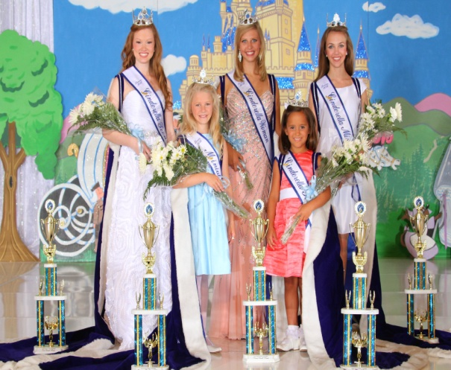

2012-13 Texas State Royalty
Lucy Ann Wilhelm, Sydney Earls,
Anna Beth Charlet, Sheridan Donevant
& Maci Greene.

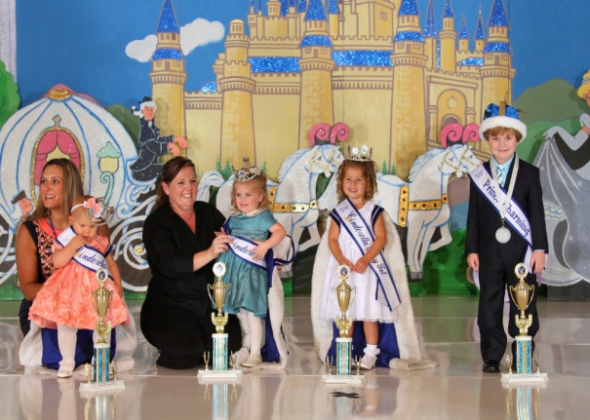

2012-13 Texas/Intl Baby Royalty
Lola Wilhelm, Sydney Watley, Katy Lynn Irwin,
& Brady Clayton – (also International Prince Charming)

Congratulations to the
2013 International Royalty
From the State of Texas…..

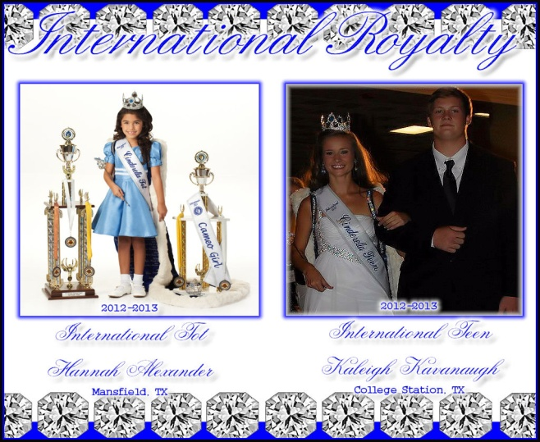

International Tot – Hannah Alexander &
International Teen – Kaleigh Kavanaugh

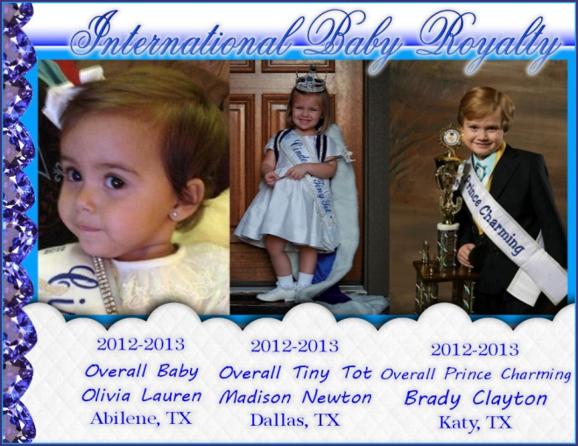

International Baby - Olivia Lauren
International Tiny Tot - Madison Newton
International Prince Charming - Brady Clayton
You’re invited to enter the…..

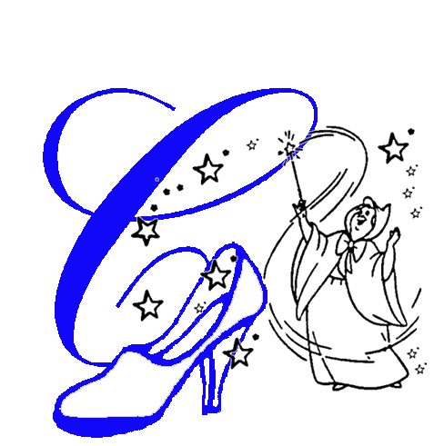

2013
Permian Basin Cinderella Prelim
Sat, March 16, 2013

Odessa College Fine Arts Auditorium
201 W. University
Odessa, TX 79764

Local Directors:
Channon Collier – 432-889-1629
Courtney Collier – 432-978-7186

Don’t miss your chance to qualify for Texas State and Join us for a year of Fun!
It’s Magic….Cinderella Magic!

